 | 1985 |  |  |  |  | 2019
 | key_spp. |  | N/A |  |  |  | key_spp. |  | N/A
Spp. | RF | HG | RF | HG | Av.1985 |  | HG | RF | HG | RF | Av.2019
AAGA |  |  | 32.70 | 14.78 | 18.70 |  |  |  | 15.34 | 18.83 | 16.26
ACER | 40.73 | 24.38 |  |  | 56.19 |  | 27.00 | 19.62 |  |  | 21.67
AFRA |  |  |  |  |  |  |  |  | 11.50 | 9.00 | 10.25
AHUM |  |  |  |  |  |  |  |  |  | 13.33 | 13.33
ALAM |  |  |  |  |  |  |  |  |  | 10.00 | 10.00
APAL | 118.59 |  |  |  | 71.93 |  |  | 90.00 |  |  | 90.00
APRO |  |  |  |  |  |  |  | 220.00 |  |  | 220.00
ATEN |  |  | 47.71 |  | 49.98 |  |  |  | 28.07 | 21.66 | 24.01
CNAT |  |  |  |  |  |  | 90.00 | 20.00 |  |  | 66.67
DLAB |  | 37.68 |  |  | 37.68 |  | 38.00 |  |  |  | 38.00
DSTO |  |  |  | 11.64 | 11.64 |  |  |  | 12.75 | 15.00 | 13.20
FFRA |  |  |  |  |  |  |  |  |  | 5.00 | 5.00
HCUC |  |  |  |  |  |  |  |  | 17.00 |  | 17.00
IRIG |  |  | 13.30 | 16.63 | 14.96 |  |  |  | 11.67 |  | 11.67
MCAV |  | 27.23 |  |  | 26.75 |  | 25.10 | 9.00 | 35.00 |  | 24.99
MLAM |  |  |  |  |  |  |  |  | 20.00 |  | 20.00
MMEA |  |  |  | 15.52 | 15.52 |  |  |  | 39.00 | 10.00 | 29.33
OANN | 53.20* | 54.41* |  |  | 45.65* |  | 18.00 |  |  |  | 18.00
OFAV |  |  |  |  |  |  | 47.30 | 18.00 |  |  | 45.90
PAST |  |  | 27.71 | 11.88 | 18.68 |  |  |  | 12.23 | 16.81 | 15.78
PDIV |  |  |  |  |  |  |  |  | 8.00 | 6.67 | 7.00
PFUR |  |  |  |  |  |  |  |  | 30.00 | 13.17 | 15.57
PPOR |  |  |  | 13.30 | 30.59 |  |  |  | 29.46 | 17.23 | 23.90
PSTR |  |  |  |  |  |  | 27.94 | 19.00 |  |  | 26.79
SBOU |  |  | 19.95 |  | 19.95 |  |  |  | 11.25 | 8.00 | 10.60
SINT |  |  |  | 6.65 | 6.65 |  |  |  | 11.53 | 18.43 | 14.86
SRAD |  |  | 51.54 | 6.65 | 31.59 |  |  |  | 5.00 | 10.56 | 10.00
SSID | 63.18 | 19.95 |  |  | 26.60 |  | 16.43 | 20.01 |  |  | 17.73
Dcli |  |  |  | 38.24 | 31.92
Dcyl |  |  |  | 39.90 | 39.90
Dstr |  | 21.06 |  |  | 33.85
Ffra |  |  |  |  | 3.33
Mdec |  |  |  |  | 7.76
Average | 82.60 | 32.25 | 39.47 | 16.93 | 42.05 |  | 23.93 | 22.43 | 16.82 | 17.19 | 18.60

(*) Diameters are referred to Montrastrea annularis spp. complex.

- Coral colony maximum diameters densities by morphologies and accretion impact sorted by geomorphic zone at Punta Maroma reef in 1985 and 2019. Bran: Branching, Digi: Digitate or digitiformes, Foli: Foliaceus or platy, Mass: massive, submass_enc: submassive or encrusting forms; RF: Reef front or accretionary zone, HG: Coral hard ground or non-accretionary zone.

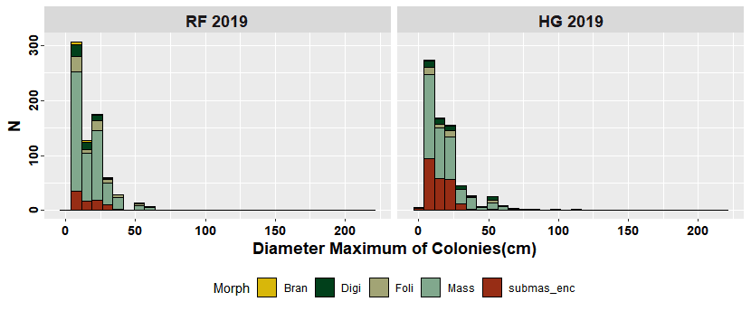

(B). Coral colony densities by morphologies and by geomorphic zone at Punta Maroma reef in 2019. Bran: Branching, Digi: Digitate or digitiformes, Foli: Foliaceus or platy, Mass: massive, submass_enc: submassive or encrusting forms; RF: Reef front or accretionary zone, HG: Coral hard ground or non-accretionary zone.

PERMDISP
Distance-based test for homogeneity of multivariate dispersions on Jaccard Similarity m

Name: jaccard
Data type: Similarity
Selection: All
Transform: Presence/absence
Resemblance: S7 Jaccard

Group factor: Temporal
Number of permutations: 9999

Number of groups: 4
Number of samples: 38

DEVIATIONS FROM CENTROID
F: 4.4716 df1: 3 df2: 34
P(perm): 0.0213

PAIRWISE COMPARISONS
Groups t P(perm)
(RF_before 1990,HG_before 1990) 1.863 0.1039
(RF_before 1990,HG_2019) 1.4109 0.1905
(RF_before 1990,RF_2019) 0.96334 0.3814
(HG_before 1990,HG_2019) 4.3492 0.0006
(HG_before 1990,RF_2019) 0.92391 0.4239
(HG_2019,RF_2019) 2.8027 0.013

MEANS AND STANDARD ERRORS
Group Size Average SE
RF_before 1990 9 34.605 3.5082
HG_before 1990 9 42.723 2.5849
HG_2019 10 29.194 1.8201
RF_2019 10 39.025 2.9985

PERMANOVA results

Source | df | SS | MS | Pseudo-F | P(perm) | perms | P(MC)
Year | 2 | 30442 | 15221 | 15.38 | 0.0001 | 9918 | 0.0001
C1 (1979)v(1985) | 1 | 2885.6 | 2885.6 | 2.1232 | 0.0425 | 9942 | 0.0705
C2 (1979,1985)v(2019) | 1 | 27556 | 27556 | 25.91 | 0.0001 | 9931 | 0.0001
Zone | 1 | 18470 | 18470 | 18.662 | 0.0001 | 9941 | 0.0001
YearxZone | 2 | 6613.8 | 3306.9 | 3.3414 | 0.0001 | 9926 | 0.0003
C1xZone | 1 | 1605.1 | 1605.1 | 1.181 | 0.3362 | 9921 | 0.3309
C2xZone | 1 | 5008.6 | 5008.6 | 4.7095 | 0.0001 | 9951 | 0.0002
Res | 32 | 31669 | 989.66
Total | 37 | 85382

PAIR-WISE TESTS

Term 'Year x Zone' for pairs of levels of factor 'Zone'

Within level '1979' of factor 'Year'
Unique
Groups t P(perm) perms P(MC)
RF, HG 2.9509 0.0083 126 0.0008
Average Similarity between/within groups
RF HG
RF 64.12
HG 21.49 40.977

Within level '1985' of factor 'Year'
Unique
Groups t P(perm) perms P(MC)
RF, HG 2.1159 0.0288 35 0.0198
Average Similarity between/within groups
RF HG
RF 43.257
HG 25.607 51.182

Within level '2019' of factor 'Year'
Unique
Groups t P(perm) perms P(MC)
RF, HG 2.8437 0.0001 9426 0.0003
Average Similarity between/within groups
RF HG
RF 58.352
HG 52.591 70.702

PERMDISP
PAIRWISE COMPARISONS
Groups | t | P(perm)
(RF_before 1990,HG_before 1990) | 1.5525 | 0.1822
(RF_before 1990,HG_2019) | 2.6637 | 0.0147
(RF_before 1990,RF_2019) | 0.59302 | 0.5981
(HG_before 1990,HG_2019) | 5.9682 | 0.0001
(HG_before 1990,RF_2019) | 2.4735 | 0.0365
(HG_2019,RF_2019) | 2.2626 | 0.0454
MEANS AND STANDARD ERRORS
Group | Size | Average | SE
RF_before 1990 | 9 | 30.692 | 4.0483
HG_before 1990 | 9 | 38.395 | 2.8688
HG_2019 | 10 | 19.662 | 1.4937
RF_2019 | 10 | 27.661 | 3.2042

